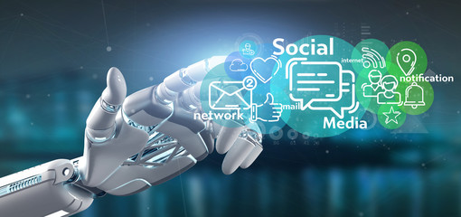

Artificial intelligence example
Social Media

Benin Ali alhajji
222431829

Atekah Hussain aljafer
222427138

Section : 66
Introduction:
Artificial intelligence refers to human-like intelligence created by a computer in the fields of technology and computer science. It describes the ability of a computer or other system to mimic the traits of the human brain by simulating its intelligence.
Artificial intelligence (AI) definition
Artificial intelligence (AI) simulates human intelligence in computers, which are then taught to think and act similarly to people. It can also be used to describe any machine that has traits like those of humans, like problem-solving and learning.
The ideal feature for Artificial Intelligence is the capacity to think, act, and accomplish a particular goal. The idea of computer systems learning from and adapting to new data without the need for human interaction is known as machine learning, which is a subset of artificial intelligence. This self-learning is made possible by deep learning algorithms, which take in a lot of unstructured input including text, photos, and video.
Machine learning and deep learning
Machine learning and deep learning fall within the larger category of artificial intelligence. Furthermore, deep learning is a subset of machine learning, as the diagram shows. Therefore, machine learning, deep learning, and AI are all merely subsets of one another. So, let's continue and see just how they differ from one another.
Artificial intelligence is a subset of machine learning. It enables computers to learn and form predictions based on their experience and data.
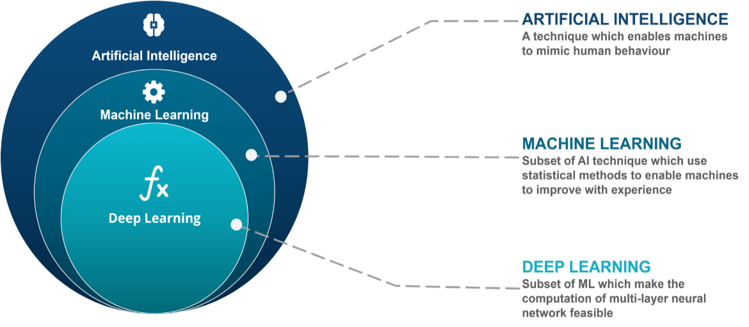
Deep learning is a specific type of machine learning that learns to represent the world as a tiered hierarchy of concepts or abstraction. Think of deep learning algorithms as a rocket engine, and the massive amounts of data that feed them as fuel.
Artificial intelligence example
- Social media
Artificial intelligence is used extensively by social networking sites like Facebook, Twitter, and Instagram for a variety of activities.
For marketers of all shades, the intersections between marketing and artificial intelligence (AI)
These social media platforms currently employ AI to tailor the content users see on their feeds. To keep users interested, the model determines their interests and suggests related information.
Artificial intelligence algorithms are used by social media platforms to customize user fees and filter out irrelevant content like hate speech and messages encouraging violence and prejudice.
Researchers have also taught AI systems to recognize hateful words, phrases, and symbols in several languages. In this approach, hate speech-containing social media posts can be quickly removed by the algorithm.

technologies have created exciting opportunities. AI has been steadily advancing into social media marketing, and for good reason. Every year, as the number of social media users grows, social media firms compete with one another to generate profits. Thus, businesses of all stripes, both large and small, have spent money on social media networks for marketing initiatives meant to increase client involvement.

The following are instances of artificial intelligence in social media:

- Emoji in prescriptive text
- To automatically tag friends in images using facial recognition
- Intelligent filter to detect and delete spam messages
- Intelligent responses for speedy message responses
Artificial intelligence will be used to detect mental health issues on a social networking platform. As an illustration, an algorithm could examine submitted and read text to find suicidal tendencies.

Target audiences were marketers
- AI in social media needs to be embraced by marketers.
Marketers use social media for a wide range of purposes to increase customer interaction, including audience growth, analyzing customers' shifting preferences and new proclivities, and finding the right message for the right audience.
The most popular social networking sites in the world, including Facebook, LinkedIn, Instagram, and Twitter, have included numerous machine learning models into its architecture.
Marketers from all industries have been fervently seeking answers to the question of how AI is changing social media. They are being compelled by ubiquity to use AI tools to amplify their social media marketing campaigns. The work ahead for creators of AI-powered products to meet the demands of social media corporations is enormous.
- Artificial intelligence's function in social media
Artificial intelligence has gained a lot of momentum in social media marketing tactics over the years. The types of social media that AI can influence are expanding thanks to expanding applications of machine learning, deep learning, cognitive computing, and natural language processing (NLP) technologies.
Social media marketing campaigns using artificial intelligence (AI) to strengthen brand engagement
Applications of AI technology are expanding the scope of social media campaigns. The transformational potential of AI tools has been directly seen by digital marketing managers as they struggle to reduce expenses and time spent on content marketing. The future of AI and social media analytics will be a part of brand strategy as content management and development take center stage in organically promoting goods and services to the target audience.
It is obvious how AI is changing social media platforms. Twitter, Facebook, and YouTube are constantly working to provide their corporate customers with the advantages of cutting-edge AI capabilities. Thus, businesses may take use of social media marketing's potential by monitoring brands, providing feedback on social media posts, and finding methods to boost campaign effectiveness all for a fraction of the price they would have paid otherwise through traditional means.
References :

https://www.edureka.co/blog/ai-vs-machine-learning-vs-deep-learning/
https://www.aitimejournal.com/@nisha.arya.ahmed/what-is-artificial-intelligence-ai
https://www.datasciencecentral.com/artificial-intelligence-in-social-media-enriches-marketing-roi/
https://yourstory.com/mystory/the-impact-of-artificial-intelligence-on-social-me
https://learnpanda.school/blog/best-real-world-examples-of-artificial-intelligence/
https://www.tycoonstory.com/technology/what-is-the-definition-of-artificial-intelligence/

